Create Responsive Layout
Send Feedback

Now that we have talked a lot about responsive layouts, its time for you to design one

You need to make 3 divs with width of '32%' and height of '300px' and margin 1%. Their colors are - '#ff8989', '#88f7ce', '#e29df2' respectively.

On screens above 600px they should appear next to each other .
otherwise they should be stacked as shown in images below.

Originally, the page will look like this on a desktop's browser -
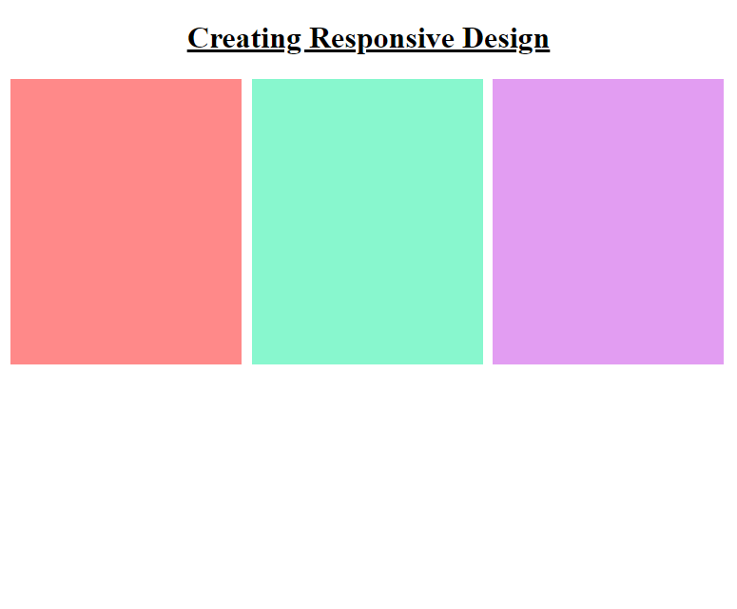

Then after the browser width decreases below 600px, the page looks like -
